Device Name: Microsoft - Surface Laptop 2

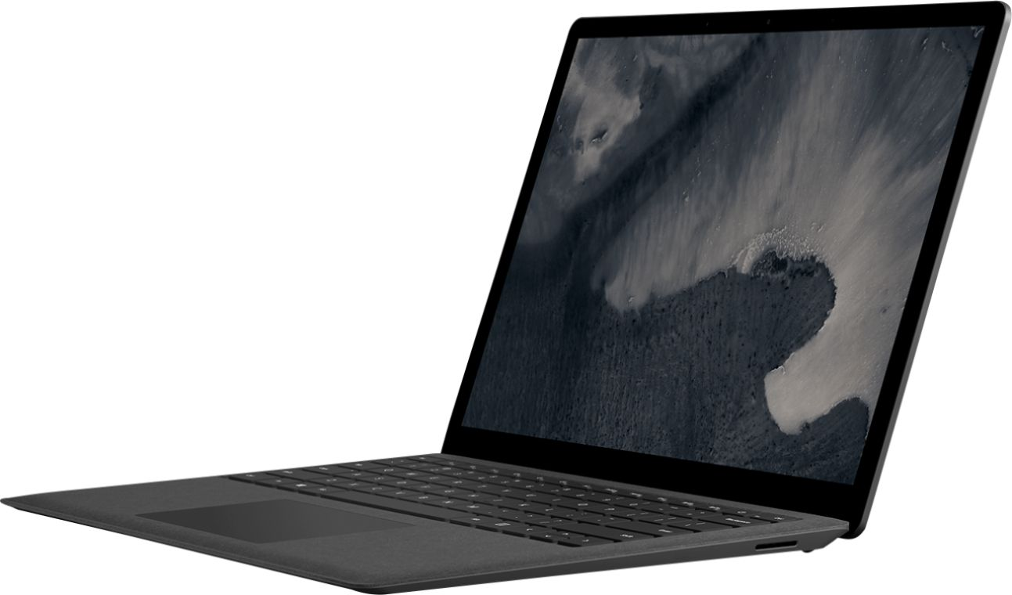

Price: $1700

**SPECIFICATIONS:**

|  |  |
| --- | --- |
| Processor: | Intel Core i5-8250U (1.6 GHz) |
| Memory: | 8 GB DDR3 |
| Storage: | 256 GB |
| Screen Size: | 13.5 |